Grade: 85

The Undesired Self

Angela K. Paolella

University of Illinois at Urbana Champaign

Richard Rockwell, Hee Sung Kim, Eline Ye

Luyao Zhang Section 289

Abstract

Briefly, the purpose of the study was to understand the relationship between the real and undesired self and the influence of discrepancies between these selves on a person’s perceived life satisfaction. The idea was to confirm or deny Ogilvie’s claim that the real and ideal self had a smaller influence on life satisfaction that that of the real and undesired self. The fifty participants were consenting friends and family members recruited by experimenters to participate in a short, online survey. Upon analysis, the data expressed significant correlations between the differences between the ought and undesired self and subjects’ reported life satisfaction totals. More specifically, the differences associated with extraversion, openness, and sympathy were the most influential factors in regards to associated life satisfaction. The data presented reflects the results reported in the original study, “The Undesired Self: A Neglected Variable in Personality Research”, conducted by Daniel Ogilvie in 1987.

*Keywords:* ought, undesired, satisfaction

Introduction

While the psychology community had already known a great deal about the relationship between the real and ideal self, not much was understood about the relationship between the real and undesired self. In other words, it became of interest to learn how the real self influences the undesired self and vice versa. More specifically we wanted to understand the implications of the discrepancies between the real and undesired self on a person’s perceived life satisfaction. In order to answer this fundamental question, I began by reading the recommended article to bolster my understanding of the topic and create an effective procedure. We contributed to the existing research by attempting to recreate the results presented in the original study, “The Undesired Self: A Neglected Variable in Personality Research”, conducted by Daniel M. Ogilvie in the late eighties. Ogilvie (1987) reported that the distance between the real and undesired self correlated, “more highly with ratings of life satisfaction than does the distance between the real and ideal selves, which suggests that satisfaction … is more a function of one’s subjective distance from unwanted affects and circumstances that a function of one’s proximity to ideal states of existence” (p. 379). To summarize, fundamental question we were trying to answer more specifically became centered upon whether or not the real and undesired self had a greater influence on life satisfaction then the real and ideal self.

The first step of testing this hypothesis was by creating an online survey, for which a template was already provided and drew heavily upon questions that measured subject’s relationship to the “Big Five personality traits”. In addition, life satisfaction was measured using a standardized test, consisting of five unique questions. To further my understanding of this assessment, I did further reading on the life satisfaction scale by reading the accompanying article provided with the standardized test. The article written by Ed Diener, gave insight on how one could conceptualize the total life satisfaction score, which was imperative to understanding what the otherwise vague scores stood for. For instance, the participants that were most satisfied with life reported scores between thirty and thirty-five which according to the author meant that subjects likely believed that, “their lives are not perfect, but they feel that that things are about as good as lives get” (Diener, 1985, p.1).

Method

The subject pool included friends and family members of the group’s four members: Richard, Hee Sung, Eline, and myself. The average age of the 50 subject sample was approximately 31.0 years old, with 26 participants being male and 24 being female. Considering the subjects were recruited regardless of gender, I was pleasantly surprised to find that we had almost evenly split the data between males and females. In order to keep the study as fair as possible, we each recruited approximately thirteen subjects, which left room for the few subjects that changed their mind about their willingness to complete the survey. As far as materials went, the study was incredibly easy to conduct, as the only thing required of ourselves and the participants was access to the internet. Many participants easily completed the survey from their mobile devices and the HTML code and data analysis was done on a desktop. Further, the procedure was also extremely simple, as all we did was create a survey using the coding template that we had used on previous laboratory assignments and ask friends and family to participate in the survey.

Results

Aside from a few missing answers, of which many were obtained by directly asking participants what their answer would have been immediately after their survey had been submitted, there were no issues associated with the HTML data collection. Below are the resulting means, standard deviations, correlations, tables, and figures for the data collected.

|  |  |  |  |
| --- | --- | --- | --- |
| **Descriptive Statistics** | | | |
|  | Mean | Std. Deviation | N |
| @36_life_satisfaction_total | 21.22 | 7.525 | 50 |
| diff_ac_un_ex | .6300 | .93574 | 50 |

|  |  |  |  |
| --- | --- | --- | --- |
| **Correlations** | | | |
|  | | @36_life_satisfaction_total | diff_ac_un_ex |
| @36_life_satisfaction_total | Pearson Correlation | 1 | .119 |
| Sig. (2-tailed) |  | .410 |
| N | 50 | 50 |
| diff_ac_un_ex | Pearson Correlation | .119 | 1 |
| Sig. (2-tailed) | .410 |  |
| N | 50 | 50 |

|  |  |  |  |
| --- | --- | --- | --- |
| **Descriptive Statistics** | | | |
|  | Mean | Std. Deviation | N |
| @36_life_satisfaction_total | 21.22 | 7.525 | 50 |
| diff_ac_ou_ex | -.0500 | 1.11689 | 50 |

|  |  |  |  |
| --- | --- | --- | --- |
| **Correlations** | | | |
|  | | @36_life_satisfaction_total | diff_ac_ou_ex |
| @36_life_satisfaction_total | Pearson Correlation | 1 | .158 |
| Sig. (2-tailed) |  | .273 |
| N | 50 | 50 |
| diff_ac_ou_ex | Pearson Correlation | .158 | 1 |
| Sig. (2-tailed) | .273 |  |
| N | 50 | 50 |

|  |  |  |  |
| --- | --- | --- | --- |
| **Descriptive Statistics** | | | |
|  | Mean | Std. Deviation | N |
| @36_life_satisfaction_total | 21.22 | 7.525 | 50 |
| diff_un_ou_ex | -.6800 | .94631 | 50 |

|  |  |  |  |
| --- | --- | --- | --- |
| **Correlations** | | | |
|  | | @36_life_satisfaction_total | diff_un_ou_ex |
| @36_life_satisfaction_total | Pearson Correlation | 1 | .069 |
| Sig. (2-tailed) |  | .635 |
| N | 50 | 50 |
| diff_un_ou_ex | Pearson Correlation | .069 | 1 |
| Sig. (2-tailed) | .635 |  |
| N | 50 | 50 |

|  |  |  |  |
| --- | --- | --- | --- |
| **Descriptive Statistics** | | | |
|  | Mean | Std. Deviation | N |
| @36_life_satisfaction_total | 21.22 | 7.525 | 50 |
| diff_ac_un_sw | .7900 | .78305 | 50 |

|  |  |  |  |
| --- | --- | --- | --- |
| **Correlations** | | | |
|  | | @36_life_satisfaction_total | diff_ac_un_sw |
| @36_life_satisfaction_total | Pearson Correlation | 1 | -.129 |
| Sig. (2-tailed) |  | .373 |
| N | 50 | 50 |
| diff_ac_un_sw | Pearson Correlation | -.129 | 1 |
| Sig. (2-tailed) | .373 |  |
| N | 50 | 50 |

|  |  |  |  |
| --- | --- | --- | --- |
| **Descriptive Statistics** | | | |
|  | Mean | Std. Deviation | N |
| @36_life_satisfaction_total | 21.22 | 7.525 | 50 |
| diff_ac_ou_sw | -.1200 | .77959 | 50 |

|  |  |  |  |
| --- | --- | --- | --- |
| **Correlations** | | | |
|  | | @36_life_satisfaction_total | diff_ac_ou_sw |
| @36_life_satisfaction_total | Pearson Correlation | 1 | -.145 |
| Sig. (2-tailed) |  | .315 |
| N | 50 | 50 |
| diff_ac_ou_sw | Pearson Correlation | -.145 | 1 |
| Sig. (2-tailed) | .315 |  |
| N | 50 | 50 |

|  |  |  |  |
| --- | --- | --- | --- |
| **Descriptive Statistics** | | | |
|  | Mean | Std. Deviation | N |
| @36_life_satisfaction_total | 21.22 | 7.525 | 50 |
| diff_ac_un_con | .9500 | .94895 | 50 |

|  |  |  |  |
| --- | --- | --- | --- |
| **Correlations** | | | |
|  | | @36_life_satisfaction_total | diff_ac_un_con |
| @36_life_satisfaction_total | Pearson Correlation | 1 | .130 |
| Sig. (2-tailed) |  | .368 |
| N | 50 | 50 |
| diff_ac_un_con | Pearson Correlation | .130 | 1 |
| Sig. (2-tailed) | .368 |  |
| N | 50 | 50 |

|  |  |  |  |
| --- | --- | --- | --- |
| **Descriptive Statistics** | | | |
|  | Mean | Std. Deviation | N |
| @36_life_satisfaction_total | 21.22 | 7.525 | 50 |
| diff_ou_un_sw | .9100 | .88462 | 50 |

|  |  |  |  |
| --- | --- | --- | --- |
| **Correlations** | | | |
|  | | @36_life_satisfaction_total | diff_ou_un_sw |
| @36_life_satisfaction_total | Pearson Correlation | 1 | .014 |
| Sig. (2-tailed) |  | .924 |
| N | 50 | 50 |
| diff_ou_un_sw | Pearson Correlation | .014 | 1 |
| Sig. (2-tailed) | .924 |  |
| N | 50 | 50 |

|  |  |  |  |
| --- | --- | --- | --- |
| **Descriptive Statistics** | | | |
|  | Mean | Std. Deviation | N |
| @36_life_satisfaction_total | 21.22 | 7.525 | 50 |
| diff_ac_un_neuro | -.8500 | .81598 | 50 |

|  |  |  |  |
| --- | --- | --- | --- |
| **Correlations** | | | |
|  | | @36_life_satisfaction_total | diff_ac_un_neuro |
| @36_life_satisfaction_total | Pearson Correlation | 1 | -.173 |
| Sig. (2-tailed) |  | .229 |
| N | 50 | 50 |
| diff_ac_un_neuro | Pearson Correlation | -.173 | 1 |
| Sig. (2-tailed) | .229 |  |
| N | 50 | 50 |

|  |  |  |  |
| --- | --- | --- | --- |
| **Descriptive Statistics** | | | |
|  | Mean | Std. Deviation | N |
| @36_life_satisfaction_total | 21.22 | 7.525 | 50 |
| diff_ac_un_open | .9300 | .95303 | 50 |

|  |  |  |  |
| --- | --- | --- | --- |
| **Correlations** | | | |
|  | | @36_life_satisfaction_total | diff_ac_un_open |
| @36_life_satisfaction_total | Pearson Correlation | 1 | .186 |
| Sig. (2-tailed) |  | .197 |
| N | 50 | 50 |
| diff_ac_un_open | Pearson Correlation | .186 | 1 |
| Sig. (2-tailed) | .197 |  |
| N | 50 | 50 |

|  |  |  |  |
| --- | --- | --- | --- |
| **Descriptive Statistics** | | | |
|  | Mean | Std. Deviation | N |
| @36_life_satisfaction_total | 21.22 | 7.525 | 50 |
| diff_ac_ou_con | -.1400 | .80204 | 50 |

|  |  |  |  |
| --- | --- | --- | --- |
| **Correlations** | | | |
|  | | @36_life_satisfaction_total | diff_ac_ou_con |
| @36_life_satisfaction_total | Pearson Correlation | 1 | .264 |
| Sig. (2-tailed) |  | .064 |
| N | 50 | 50 |
| diff_ac_ou_con | Pearson Correlation | .264 | 1 |
| Sig. (2-tailed) | .064 |  |
| N | 50 | 50 |

|  |  |  |  |
| --- | --- | --- | --- |
| **Descriptive Statistics** | | | |
|  | Mean | Std. Deviation | N |
| @36_life_satisfaction_total | 21.22 | 7.525 | 50 |
| diff_ac_ou_neuro | .5500 | .95431 | 50 |

|  |  |  |  |
| --- | --- | --- | --- |
| **Correlations** | | | |
|  | | @36_life_satisfaction_total | diff_ac_ou_neuro |
| @36_life_satisfaction_total | Pearson Correlation | 1 | -.419** |
| Sig. (2-tailed) |  | .002 |
| N | 50 | 50 |
| diff_ac_ou_neuro | Pearson Correlation | -.419** | 1 |
| Sig. (2-tailed) | .002 |  |
| N | 50 | 50 |
| **. Correlation is significant at the 0.01 level (2-tailed). | | | |

|  |  |  |  |
| --- | --- | --- | --- |
| **Descriptive Statistics** | | | |
|  | Mean | Std. Deviation | N |
| @36_life_satisfaction_total | 21.22 | 7.525 | 50 |
| diff_ac_ou_open | .1000 | .74231 | 50 |

|  |  |  |  |
| --- | --- | --- | --- |
| **Correlations** | | | |
|  | | @36_life_satisfaction_total | diff_ac_ou_open |
| @36_life_satisfaction_total | Pearson Correlation | 1 | .277 |
| Sig. (2-tailed) |  | .051 |
| N | 50 | 50 |
| diff_ac_ou_open | Pearson Correlation | .277 | 1 |
| Sig. (2-tailed) | .051 |  |
| N | 50 | 50 |

|  |  |  |  |
| --- | --- | --- | --- |
| **Descriptive Statistics** | | | |
|  | Mean | Std. Deviation | N |
| @36_life_satisfaction_total | 21.22 | 7.525 | 50 |
| diff_ou_un_open | .8300 | .91255 | 50 |

|  |  |  |  |
| --- | --- | --- | --- |
| **Correlations** | | | |
|  | | @36_life_satisfaction_total | diff_ou_un_open |
| @36_life_satisfaction_total | Pearson Correlation | 1 | -.032 |
| Sig. (2-tailed) |  | .828 |
| N | 50 | 50 |
| diff_ou_un_open | Pearson Correlation | -.032 | 1 |
| Sig. (2-tailed) | .828 |  |
| N | 50 | 50 |

|  |  |  |  |
| --- | --- | --- | --- |
| **Descriptive Statistics** | | | |
|  | Mean | Std. Deviation | N |
| @36_life_satisfaction_total | 21.22 | 7.525 | 50 |
| diff_ou_un_neuro | -1.4000 | .97938 | 50 |

|  |  |  |  |
| --- | --- | --- | --- |
| **Correlations** | | | |
|  | | @36_life_satisfaction_total | diff_ou_un_neuro |
| @36_life_satisfaction_total | Pearson Correlation | 1 | .264 |
| Sig. (2-tailed) |  | .064 |
| N | 50 | 50 |
| diff_ou_un_neuro | Pearson Correlation | .264 | 1 |
| Sig. (2-tailed) | .064 |  |
| N | 50 | 50 |

|  |  |  |  |
| --- | --- | --- | --- |
| **Descriptive Statistics** | | | |
|  | Mean | Std. Deviation | N |
| @36_life_satisfaction_total | 21.22 | 7.525 | 50 |
| diff_ou_un_con | 1.0900 | 1.12345 | 50 |

|  |  |  |  |
| --- | --- | --- | --- |
| **Correlations** | | | |
|  | | @36_life_satisfaction_total | diff_ou_un_con |
| @36_life_satisfaction_total | Pearson Correlation | 1 | -.078 |
| Sig. (2-tailed) |  | .588 |
| N | 50 | 50 |
| diff_ou_un_con | Pearson Correlation | -.078 | 1 |
| Sig. (2-tailed) | .588 |  |
| N | 50 | 50 |

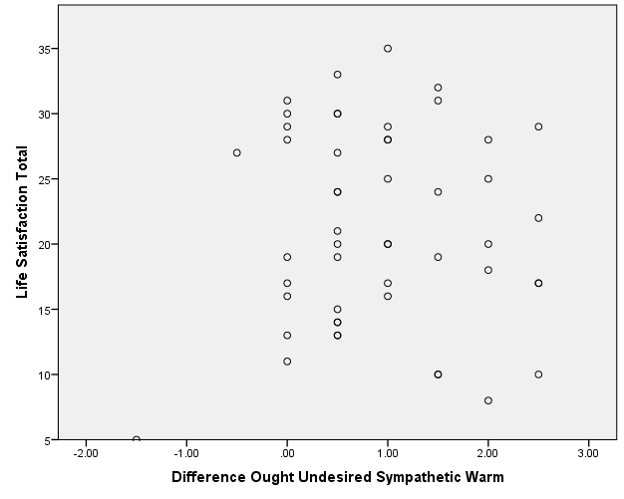  
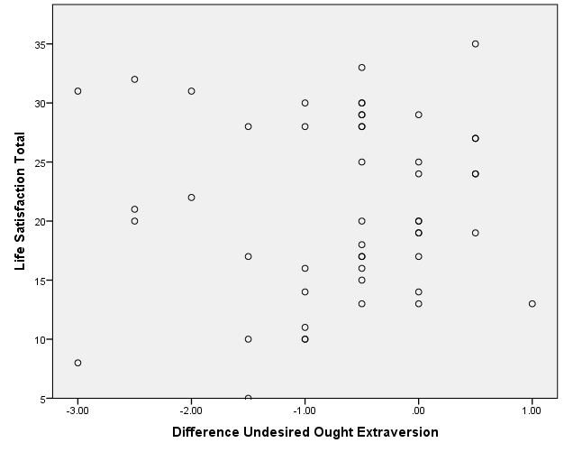



Discussion

As previously mentioned, we wanted to see if we could further the research that Ogilvie presented in his publication by measuring the differences between each of the three selves and the associated total scores of life satisfaction. We found that the greatest correlations reported were related to the differences between the ought and undesired self. As shown above in the reported tables, these discrepancies, when involving extraversion, openness, and sympathy had the largest impact on one’s perceived life satisfaction. In hindsight, I believe it would be of value to research the influence of the quality of one’s upbringing on the differences between the real and undesired self; I hypothesize that negative experiences during childhood, such as being considered an outcast at school or being neglected by caregivers, would increase the difference between one’s selves and in turn be correlated with a lower life satisfaction score. I do not believe our findings were significantly limited by the methods and procedures used, however it might be a good idea to increase the sample size for subsequent recreations of the study. This all said, I also speculated that random selection of subjects would be a better way to go about recruitment and potentially prevent skewed data due to selection bias. Further, I suggest that those interested in continuing research on this particular topic spend a good deal of time reading existing publications on the subject since I feel I could have formulated a much better set of research questions and modified my procedure as such. Certainly, a deeper understanding of research methods would have helped immensely with the analysis of the reported data, as I found myself overwhelmed by the numerous steps required during data analysis. Lastly, I found reading the accompanying life satisfaction article invaluable, as a set of life satisfaction totals taken out of context would have told me very little about the influence of such due to self-differences.

References

Diener, E., Emmons, R. A., Larsen, R. J., & Griffin, S. (1985). The satisfaction with life scale.

Journal of Personality Assessment, 49(1), 71-75.

Ogilvie, D. M. (1987). The undesired self: a neglected variable in personality research. Journal of

Personality and Social Psychology, 52(2), 379-385.